CTU01- Metrology of Electrical Quantities

Prof. Ing. Jaroslav Boháček, DrSc.

Czech Technical University in Prague
Faculty of Electrical Engineering (CTU FEE)
Department of Measurement
Technicka 2,
CZ-166 27 Praha 6, Czech Republic

We will meet on 19 November at 9:00 in the room A3-318 at the above address.

How to get to us:
Map:
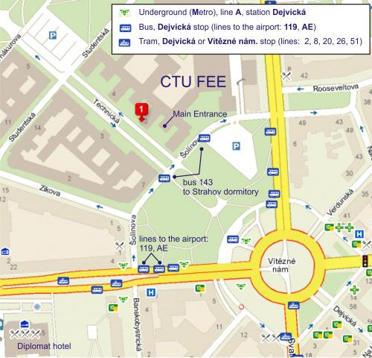
From the A plus hostel: Underground (Metro) line C to Museum (2-st)
Change to the line A and go to the Dejvicka station.

