CTU10- The PIV Method in Fluid Mechanics

Prof. Ing. Jiří Nožička CSc., Ing Jan Novotný Ph.D.
Czech Technical University in Prague
Faculty of Mechanical Engineering (CTU FME)
Department of Fluid Dynamics and Termodynamics
Technicka 4,
CZ-166 27 Praha 6, Czech Republic

How to get to us:
Map: 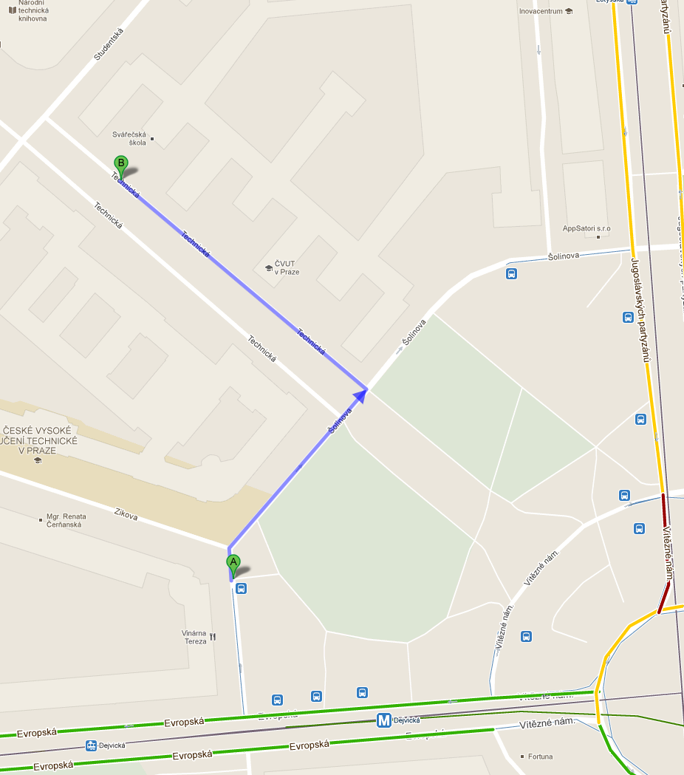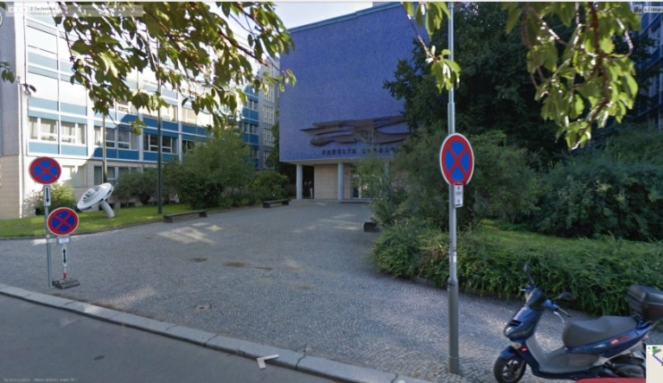
Meeting point in lobby of Faculty of Mechanical Engineering CTU in Prague, Monday 19.3. 2018 at 10 00
Output station Dejvická
From the A plus hostel: Underground (Metro) line C to Museum (2-st)
Change to the line A and go to the Dejvicka station.

