CTU14 – Data Compression

Prof. Ing. Jan Holub, Ph.D
Phone: 420 224 359 814

Czech Technical University, Faculty of Information Technology

Classes will be held in the building of the Faculty of Civil Engineering,
Thákurova 7, 160 00 Prague 6
Meeting time: Monday, November 19, 2018, at 9:00
Meeting point: reception of the Faculty of Civil Engineering (at the foyer).

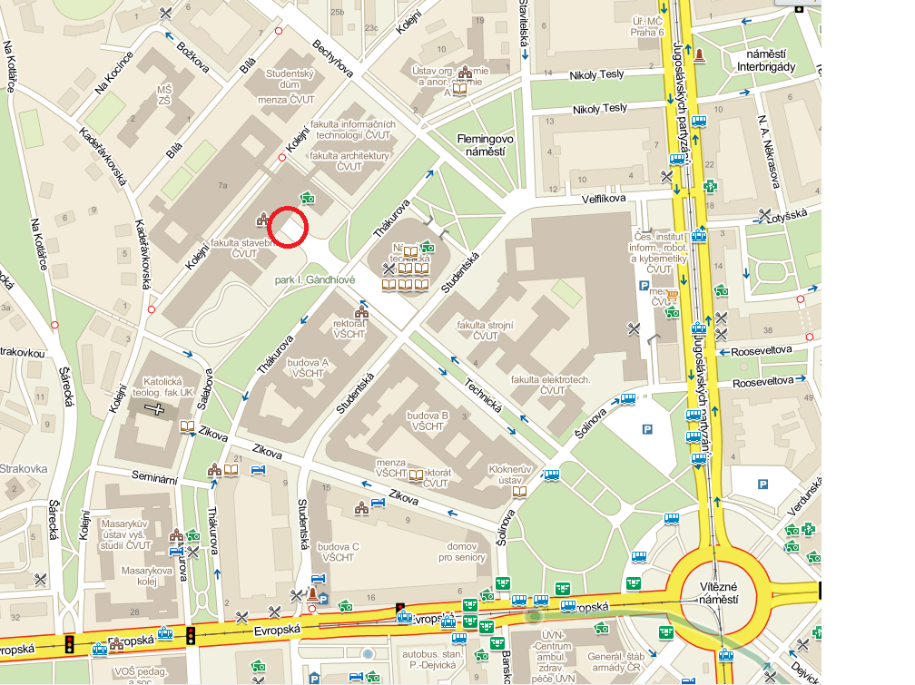

How to get – from the A plus hostel:
Underground (Metro) line C to Museum (2-st)
Change to the line A and go to the station Dejvicka (final stop)

