CTU18 – Physics of Extreme Systems

Teacher: Prof. Ing. Ladislav Drška, DrSc.
Address: Building of the Faculty of Nuclear Science and Physical Engineering Trojanova 13, Praha 2

Classroom: T-121, Department of Physical Electronics
Meeting time: Monday, November 19, 2018 at 9:00 a.m.
Meeting point: Foyer of the faculty at 9:00

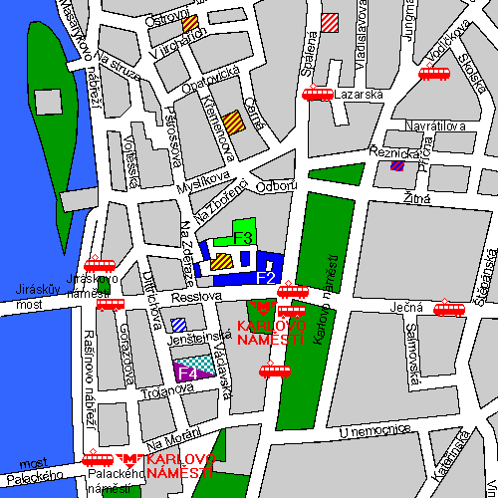

traffic direction from the A Plus hostel:
underground (Metro) line B to the station Karlovo náměstí

