CTU19 – Introduction to Vibrational Spectroscopy

Address:
University of Chemistry and Technology (in Czech VŠCHT, abbr. UCT Prague)
Technická 5
166 28 Prague 6
The buildings of VŠCHT are situated in the northwest direction of metro station Dejvická, near Vítězné náměstí in Prague 6.
The university occupies three buildings in Dejvice (see the map below):
- Building A - Technická 5 – ATHENS course
- Building B - Technická 3
- Building C - Studentská 6
How to get to VŠCHT:
From the Aplus hostel:
Metro line B, destination Zličín; change for line A at the station Můstek, destination Dejvická. The trip takes approx. 25 min.
The following map shows the location of our buildings in Dejvice (from metro Dejvická):
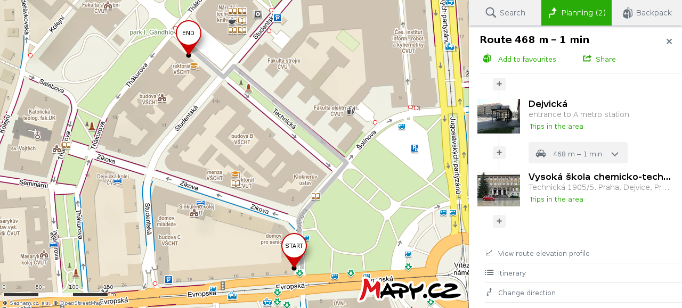

Meeting point: Monday March 18, 2019, 8:50 AM
at porter's lodge of building A,
University of Chemistry and Technology,
Technicka 5, Prague 6

