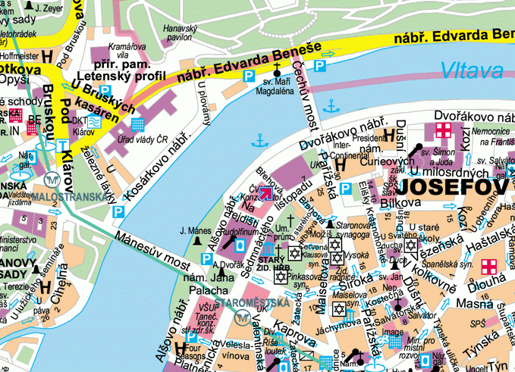

CTU2 - Application of Ionizing Radiation
Teacher: Prof. Ing. Tomáš Čechák, CSc.
Address: Břehová 7, Prague 1
Building of the Faculty of Nuclear Science and Physical Engineering

Meeting time: Monday, March 18, at 8:50, in a foyer
Courses: Room 111, 1. floor, at 9:00
Five-minute walk from Metro Line A Staroměstská station

